|  |  |  |  |  |  |
| --- | --- | --- | --- | --- | --- |
| Table 1: Sample Means for Project STAR Students and Classes by Year of Entry and Initial Class Type | | | | | |
|  | (1) | (2) | (3) | (4) | (5) |
| Panel A: Students who Entered STAR in Kindergarten | | | | | |
|  | Small | Regular | Regular/Aide | Joint P-Value | Within-school Joint P-value |
| Free lunch | 0.471 | 0.480 | 0.501 | 0.128 | 0.484 |
| White/Asian Student | 0.683 | 0.674 | 0.658 | 0.249 | 0.639 |
| Age on October 1, 1985 | 5.058 | 5.050 | 5.054 | 0.664 | 0.806 |
| Class size in kindergarten | 15.12 | 22.37 | 22.75 | 0.000** | 0.000** |
| Urban school | 0.305 | 0.309 | 0.325 | 0.585 |  |
| White/Asian teacher | 0.861 | 0.805 | 0.851 | 0.529 | 0.363 |
| Teacher has postgraduate degree | 0.313 | 0.364 | 0.363 | 0.638 | 0.556 |
| Teacher experience | 8.911 | 9.049 | 9.745 | 0.550 | 0.296 |
| Special education in kindergarten | 0.038 | 0.031 | 0.029 | 0.246 | 0.424 |
| Special instruction in kindergarten | 0.056 | 0.041 | 0.045 | 0.078* | 0.112 |
| Days present in kindergarten | 156.4 | 156.9 | 156.1 | 0.556 | 0.184 |
| Days absent in kindergarten | 10.02 | 10.53 | 10.87 | 0.019** | 0.015** |
| Missing data | 0.012 | 0.025 | 0.024 | 0.002** | 0.015** |
|  |  |  |  |  |  |
| Observations (Nonmissing) | 1,878 | 2,139 | 2,178 | 6,195 | 6,195 |
| Observations (Total) | 1,900 | 2,194 | 2,231 | 6,325 | 6,325 |
| Classrooms | 127 | 98 | 98 | 323 | 323 |
| Schools | 79 | 78 | 79 | 79 | 79 |
|  |  |  |  |  |  |
| Panel B: Students who Entered STAR in First Grade | | | | | |
|  | Small | Regular | Regular/Aide | Joint P-Value | Within-school Joint P-value |
| Free lunch | 0.595 | 0.626 | 0.606 | 0.513 | 0.407 |
| White/Asian Student | 0.612 | 0.556 | 0.651 | 0.000** | 0.145 |
| Age on October 1, 1985 | 5.380 | 5.481 | 5.503 | 0.003** | 0.011** |
| Class size in first grade | 15.78 | 22.70 | 23.36 | 0.000** | 0.000* |
| Urban school | 0.318 | 0.326 | 0.317 | 0.967 |  |
| White/Asian teacher | 0.816 | 0.780 | 0.795 | 0.851 | 0.561 |
| Teacher has postgraduate degree | 0.316 | 0.332 | 0.369 | 0.764 | 0.742 |
| Teacher experience | 12.88 | 10.04 | 12.17 | 0.096* | 0.026** |
| Special education in first grade | 0.011 | 0.022 | 0.025 | 0.178 | 0.439 |
| Special instruction in first grade | 0.187 | 0.238 | 0.205 | 0.073* | 0.068* |
| Days present in first grade | 130.9 | 139.5 | 142.0 | 0.000** | 0.000* |
| Days absent in first grade | 8.360 | 7.779 | 7.781 | 0.527 | 0.947 |
| Missing data | 0.070 | 0.052 | 0.066 | 0.266 | 0.459 |
|  |  |  |  |  |  |
| Observations (Nonmissing) | 358 | 973 | 843 | 2,174 | 2,174 |
| Observations (Total) | 385 | 1,026 | 903 | 2,314 | 2,314 |
| Classrooms | 106 | 115 | 98 | 319 | 319 |
| Schools | 68 | 76 | 71 | 76 | 76 |
|  |  |  |  |  |  |
| Panel C: Students who Entered STAR in Second Grade | | | | | |
|  | Small | Regular | Regular/Aide | Joint P-Value | Within-school Joint P-value |
| Free lunch | 0.650 | 0.621 | 0.652 | 0.499 | 0.677 |
| White/Asian Student | 0.574 | 0.568 | 0.490 | 0.012** | 0.356 |
| Age on October 1, 1985 | 5.526 | 5.550 | 5.577 | 0.544 | 0.227 |
| Class size in second grade | 15.50 | 23.62 | 23.74 | 0.000** | 0.000** |
| Urban school | 0.332 | 0.328 | 0.394 | 0.357 |  |
| White/Asian teacher | 0.779 | 0.737 | 0.737 | 0.791 | 0.603 |
| Teacher has postgraduate degree | 0.296 | 0.303 | 0.535 | 0.005** | 0.008** |
| Teacher experience | 12.60 | 12.61 | 13.48 | 0.768 | 0.788 |
| Missing data | 0.096 | 0.106 | 0.164 | 0.001** | 0.121 |
|  |  |  |  |  |  |
| Observations (Nonmissing) | 331 | 585 | 551 | 1,467 | 1,467 |
| Observations (Total) | 366 | 654 | 659 | 1,679 | 1,679 |
| Classrooms | 111 | 95 | 98 | 304 | 304 |
| Schools | 70 | 69 | 72 | 73 | 73 |

Notes to Table 1: Data source is Project STAR dataset. Tables are structured after Tables 1 and 2 of Krueger (1999) but with different variables and sample definitions. Small, regular, and regular/aide indicate the student’s class type in the first year in Project STAR. “Special instruction” indicates that student was pulled out for special instruction in that grade. Urban school and teacher characteristics are measured for the first year the student was in Project STAR. Data on special education, special instruction, days present, and days absent are not available for second grade. Sample includes those observations with non-missing values for the variables shown; sample for the “missing data” dummy includes all observations. Schools that left the program by third grade are excluded from the sample. For students entering Project STAR in kindergarten and first grade, most of the missing observations come from missing data on special education or instruction or days present or absent. For students entering the program in second grade, the missing observations come from missing data on free lunch, race, and teacher experience.Column (4) shows the p-value for an F-test of the null hypothesis that the means are equal across the three groups; ** indicates that the null hypothesis is rejected at the 5% significance level, and * indicates that the null hypothesis is rejected at the 10% level. Column (5) shows the p-value for the same F-test after controlling for fixed effects for students’ schools in their first year in the program. For individual student characteristics (free lunch, white/Asian student, special education, special instruction, days present, days absent, and missing data), robust standard errors are used. For urban school, the standard errors adjust for clustering at the school level, and for the classroom-level variables (class size, white/Asian teacher, teacher has postgraduate degree, and teacher experience), the standard errors adjust for clustering by teacher (the id of the teacher for the first year in the program).

|  |  |  |  |  |  |  |  |  |  |  |
| --- | --- | --- | --- | --- | --- | --- | --- | --- | --- | --- |
| Table 2: OLS Estimates of Effects of Class Type on Attrition | | | | | | | | | | |
|  | (1) | (2) | (3) | (4) | (5) | (6) | (7) | (8) | (9) | (10) |
| Panel A: Entered Project STAR in Kindergarten, Clusters = 307 | | | | | | | | | | |
| Initial Class Type | Left Assigned Class Type, School, or Grade in First Year | | Left Assigned School or Grade in First Year | | Left Assigned Class Type, School, or Grade by Third Grade | | Left Assigned School or Grade by Third Grade | | Left Public School System by 1990 | |
| Small | -0.041 | -0.055 | -0.033 | -0.048 | -0.050 | -0.058 | -0.021 | -0.033 | -0.010 | -0.018 |
|  | (0.026) | (0.015)** | (0.023) | (0.013)** | (0.029)* | (0.015)** | (0.027) | (0.013)** | (0.036) | (0.012) |
|  |  |  |  |  |  |  |  |  |  |  |
| Regular | -0.014 | -0.025 | -0.006 | -0.017 | 0.016 | 0.008 | 0.021 | 0.009 | 0.020 | -0.009 |
| w/ Aide | (0.025) | (0.014)* | (0.023) | (0.012) | (0.028) | (0.014) | (0.027) | (0.013) | (0.039) | (0.011) |
|  |  |  |  |  |  |  |  |  |  |  |
| R2 | 0.001 | 0.102 | 0.001 | 0.097 | 0.003 | 0.137 | 0.001 | 0.131 | 0.001 | 0.283 |
|  |  |  |  |  |  |  |  |  |  |  |
| Panel B: Entered Project STAR in Grade 1, Clusters = 314 | | | | | | | | | | |
| Small | 0.008 | 0.012 | 0.049 | 0.054 | -0.041 | -0.040 | 0.023 | 0.026 | 0.051 | 0.064 |
|  | (0.036) | (0.032) | (0.032) | (0.028)* | (0.038) | (0.032) | (0.036) | (0.029) | (0.045) | (0.026)** |
|  |  |  |  |  |  |  |  |  |  |  |
| Regular | -0.082 | -0.057 | -0.044 | -0.025 | -0.123 | -0.086 | -0.058 | -0.023 | -0.037 | 0.002 |
| w/ Aide | (0.030)** | (0.021)** | (0.025)* | (0.018) | (0.032)** | (0.022)** | (0.030)* | (0.019) | (0.041) | (0.017) |
|  |  |  |  |  |  |  |  |  |  |  |
| R2 | 0.007 | 0.109 | 0.0047 | 0.095 | 0.013 | 0.142 | 0.004 | 0.125 | 0.004 | 0.274 |
|  |  |  |  |  |  |  |  |  |  |  |
| Panel C: Entered Project STAR in Grade 2, Clusters = 304 | | | | | | | | | | |
| Small |  |  |  |  | -0.006 | -0.017 | 0.023 | 0.015 | 0.000 | 0.019 |
|  |  |  |  |  | (0.040) | (0.036)** | (0.035) | (0.032) | (0.047) | (0.030) |
|  |  |  |  |  |  |  |  |  |  |  |
| Regular |  |  |  |  | -0.044 | -0.064 | 0.003 | -0.010 | 0.008 | -0.027 |
| w/ Aide |  |  |  |  | (0.035) | (0.030)** | (0.031) | (0.024) | (0.050) | (0.024) |
|  |  |  |  |  |  |  |  |  |  |  |
| R2 |  |  |  |  | 0.002 | 0.102 | 0.000 | 0.090 | 0.000 | 0.260 |
|  |  |  |  |  |  |  |  |  |  |  |
| Controls? |  | Yes |  | Yes |  | Yes |  | Yes |  | Yes |
| School Fixed Effects? | | Yes |  | Yes |  | Yes |  | Yes |  | Yes |

Notes to Table 2: Within each panel, each column shows results from a different linear regression in which the regressor of interest are class type in first year in Project STAR. Standard errors adjust for clustering by first STAR year teacher id. Sample excludes students with missing values for the variables shown in Table 1 and those whose schools left Project STAR by third grade. “Left assigned class type, school, or grade” is defined as in Figure 2; switches between regular and regular with aide are not counted as switches in class type. “Left public school system” indicates whether the student took the TCAP in 1990, as measured from the TCAP data. “Controls” include free lunch recipient, white/Asian student, age on October 1, 1985, white/Asian teacher, teacher has postgraduate degree, and teacher experience.

|  |  |  |  |  |  |  |  |  |  |  |
| --- | --- | --- | --- | --- | --- | --- | --- | --- | --- | --- |
| Table 3: OLS Estimates of Effects of Initial Class Type on Later Class Type, Grade Repetition, and Public School Performance | | | | | | | | | | |
|  | (1) | (2) | (3) | (4) | (5) | (6) | (7) | (8) | (9) | (10) |
| Panel A: Entered Project STAR in Kindergarten | | | | | | | | | | |
| Initial Class Type | In STAR in Small Class After First Year | In STAR in Small Class in Third Grade | In STAR in Class with Aide after First Year | In STAR in Class with Aide in Third Grade | Above Median Test Score and Left Assigned School After First Year | Below Median Test Score and Left Assigned School After First Year | Repeat Grade Recommended while in STAR | Took TCAP After 1995 | In Public School System at or Above Grade Level in 1990 | In Public School System Below Grade Level in 1990 |
| Small | 0.660 | 0.422 | -0.298 | -0.217 | -0.009 | -0.040 | -0.015 | -0.002 | 0.015 | 0.003 |
|  | (0.016)** | (0.017)** | (0.012)** | (0.011)** | (0.009) | (0.012)** | (0.010) | (0.010) | (0.013) | (0.009) |
|  |  |  |  |  |  |  |  |  |  |  |
| Regular | 0.001 | 0.006 | 0.006 | 0.006 | -0.012 | -0.008 | -0.001 | 0.008 | 0.005 | 0.004 |
| w/ Aide | (0.011) | (0.012) | (0.013) | (0.011) | (0.009) | (0.011) | (0.010) | (0.009) | (0.012) | (0.007) |
|  |  |  |  |  |  |  |  |  |  |  |
| R2 | 0.497 | 0.257 | 0.151 | 0.109 | 0.073 | 0.092 | 0.128 | 0.059 | 0.235 | 0.063 |
|  |  |  |  |  |  |  |  |  |  |  |
| Panel B: Entered Project STAR in Grade 1, Clusters = 314 | | | | | | | | | | |
| Small | 0.519 | 0.355 | -0.056 | -0.045 | -0.005 | 0.056 | -0.020 | -0.012 | -0.024 | -0.040 |
|  | (0.031)** | (0.032)** | (0.018)** | (0.017)** | (0.022) | (0.026)** | (0.023) | (0.021) | (0.024) | (0.016)** |
|  |  |  |  |  |  |  |  |  |  |  |
| Regular | -0.042 | -0.062 | 0.540 | 0.402 | 0.004 | -0.027 | -0.031 | -0.017 | 0.014 | -0.016 |
| w/ Aide | (0.014)** | (0.015)** | (0.026)** | (0.024)** | (0.013) | (0.018) | (0.016)* | (0.013) | (0.016) | (0.013) |
|  |  |  |  |  |  |  |  |  |  |  |
| R2 | 0.396 | 0.263 | 0.402 | 0.297 | 0.074 | 0.103 | 0.091 | 0.093 | 0.236 | 0.100 |
|  |  |  |  |  |  |  |  |  |  |  |
| Panel C: Entered Project STAR in Grade 2, Clusters = 304 | | | | | | | | | | |
| Small | 0.569 | 0.569 |  | -0.047 | 0.009 | -0.006 | -0.025 | -0.008 | -0.014 | -0.005 |
|  | (0.028)** | (0.028)** |  | (0.025)* | (0.018) | (0.029) | (0.017) | (0.018) | (0.029) | (0.011) |
|  |  |  |  |  |  |  |  |  |  |  |
| Regular | -0.056 | -0.056 |  | 0.575 | 0.014 | -0.024 | -0.049 | -0.010 | 0.034 | -0.008 |
| w/ Aide | (0.016)** | (0.016)** |  | (0.030)** | (0.015) | (0.020) | (0.018)** | (0.015) | (0.023) | (0.011) |
|  |  |  |  |  |  |  |  |  |  |  |
| R2 | 0.500 | 0.500 |  | 0.450 | 0.070 | 0.118 | 0.091 | 0.085 | 0.268 | 0.087 |
|  |  |  |  |  |  |  |  |  |  |  |
| Controls? | Yes | Yes | Yes | Yes | Yes | Yes | Yes | Yes | Yes | Yes |
| School Fixed Effects? | Yes | Yes | Yes | Yes | Yes | Yes | Yes | Yes | Yes | Yes |

Notes to Table 3: Within each panel, each column shows results from a OLS regression with controls and school fixed effects and a different outcome variable. Above or below median test scores in columns (5) and (6) measure whether the student’s average (across non-missing observations) of reading and math scores fell above or below the median among non-missing scores that year. Grade repetition variables in columns (7) and (8) are defined in the same way as in Figure 5. Grade level in 1990 is taken from TCAP data.

Figure 1: Demand for Private School for Parents in the Tennessee STAR Experiment

Demand for private school if child is in small class

Demand for private school if child is in regular-sized class

$$P^{*}$$

Tuition

Private school attendance

Observed difference in quantity demanded

Marginal surplus (MS) for parents on the margin of sending child to private school

Figure 2: Fraction Still in Assigned Grade, Class Type, and School by Year of Entry into Project STAR and Grade

Panel A: Entered Project STAR in Grade K Panel B: Entered Project STAR in Grade 1

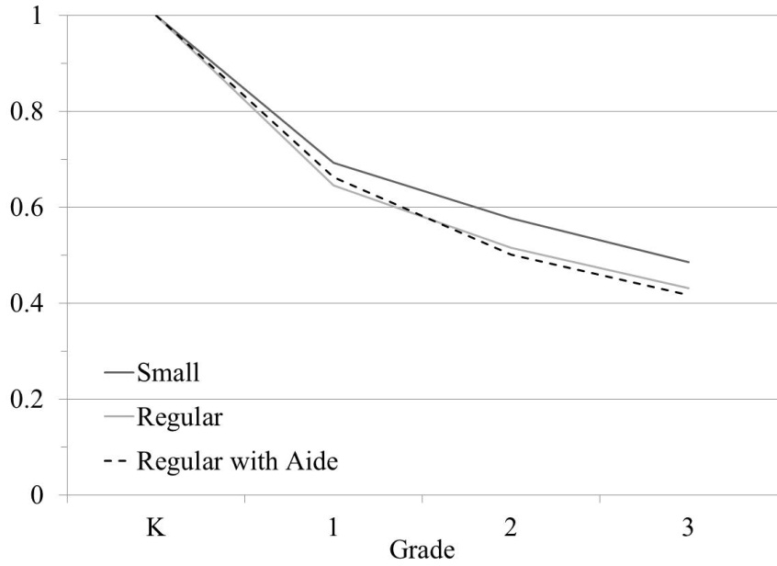 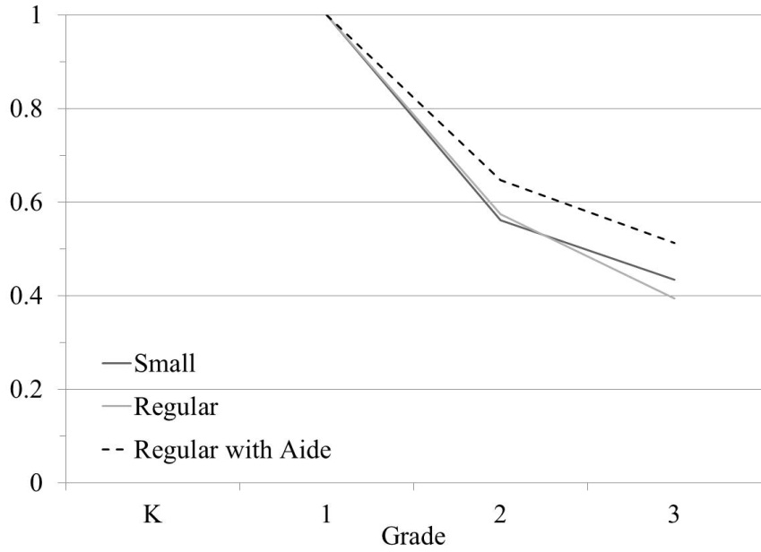

Panel C: Entered Project STAR in Grade 2

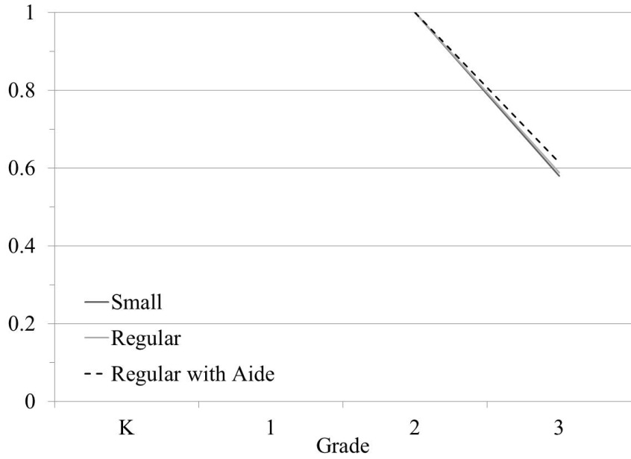

Notes to Figure 2: Data source is Tennessee STAR program data. Changes between regular and regular with aide classes are not categorized as changes in class type. Students from schools that left Project STAR are excluded from the sample. Additional details in the text.

Figure 3: Status in Third Grade by Year of Entry and Initial Class Assignment in Project STAR

Panel K-A: Entered in Grade K Panel K-B: Entered in Grade K Panel K-C: Entered in Grade K

Initially in Small Class Initially in Regular Class Initially in Regular Class w/ Aide

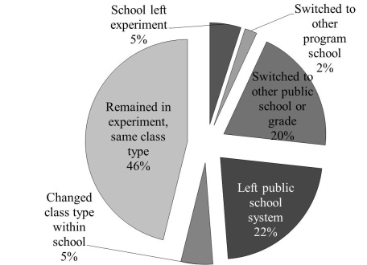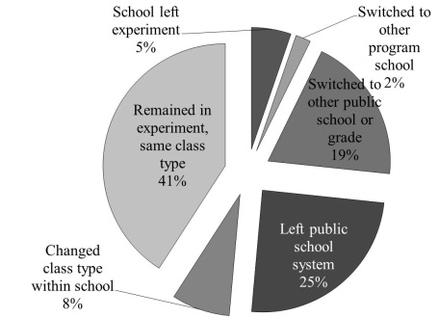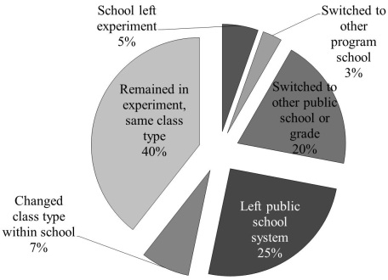

Panel 1-A: Entered in Grade 1 Panel 1-B: Entered in Grade 1 Panel 1-C: Entered in Grade 1

Initially in Small Class Initially in Regular Class Initially in Regular Class w/ Aide

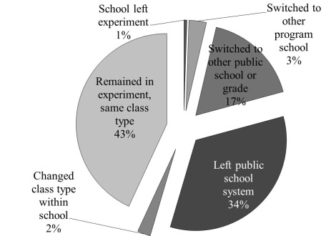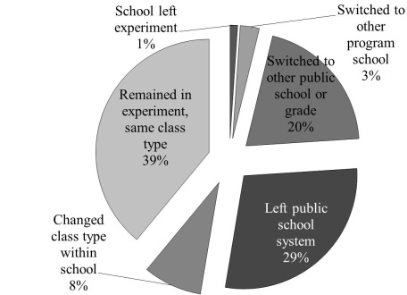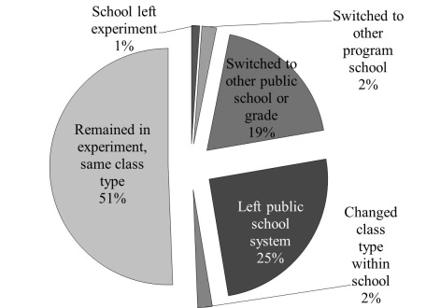

Panel 2-A: Entered in Grade 2 Panel 2-B: Entered in Grade 2 Panel 2-C: Entered in Grade 2

Initially in Small Class Initially in Regular Class Initially in Regular Class w/ Aide

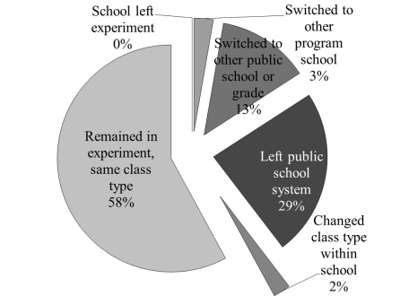 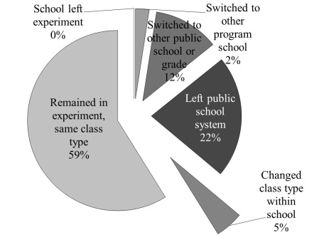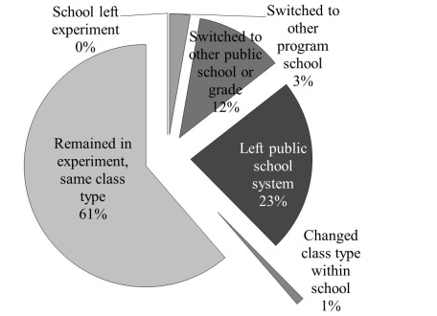

Notes to Figure 3: For the purposes of this graph, transitions between regular and regular with aide classes are not counted as changes in class type. Students are counted as having left the public school system if they do not appear in Project STAR in third grade and TCAP scores are not available for them in 1990 (the year in which most students from the cohort were in fourth grade). Additional details in the text.

Figure 4: Transitions across Class Types within Project STAR Schools

Panel A: Entered Project STAR in Grade K Panel B: Entered Project STAR in Grade 2

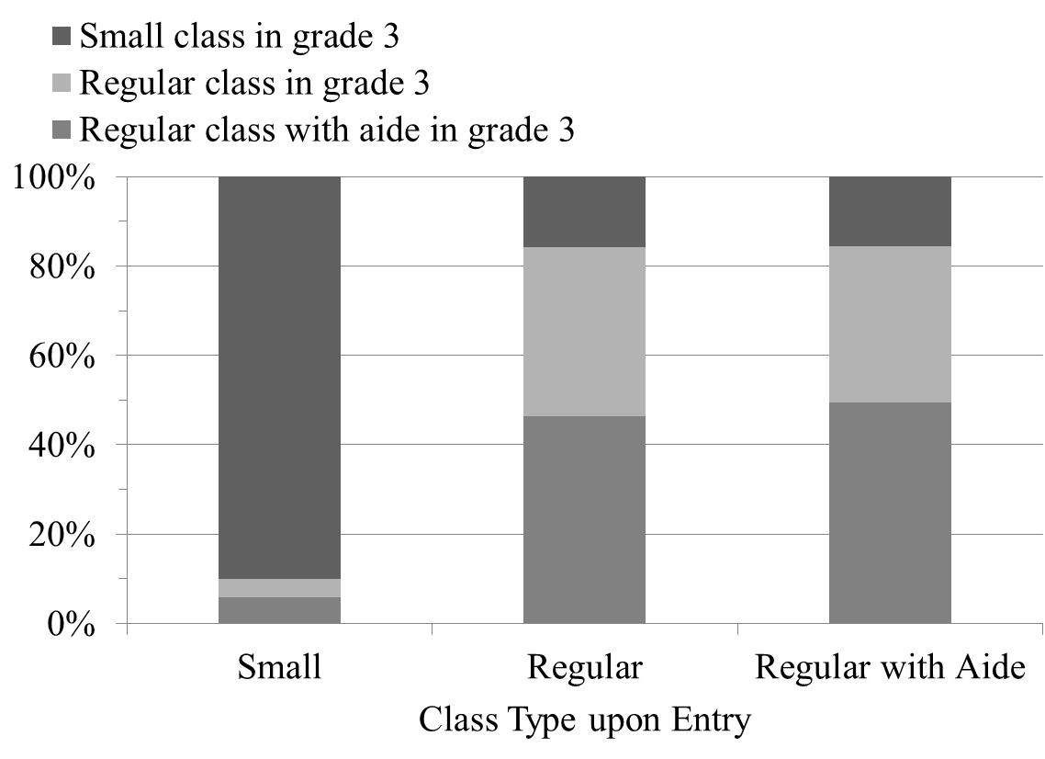 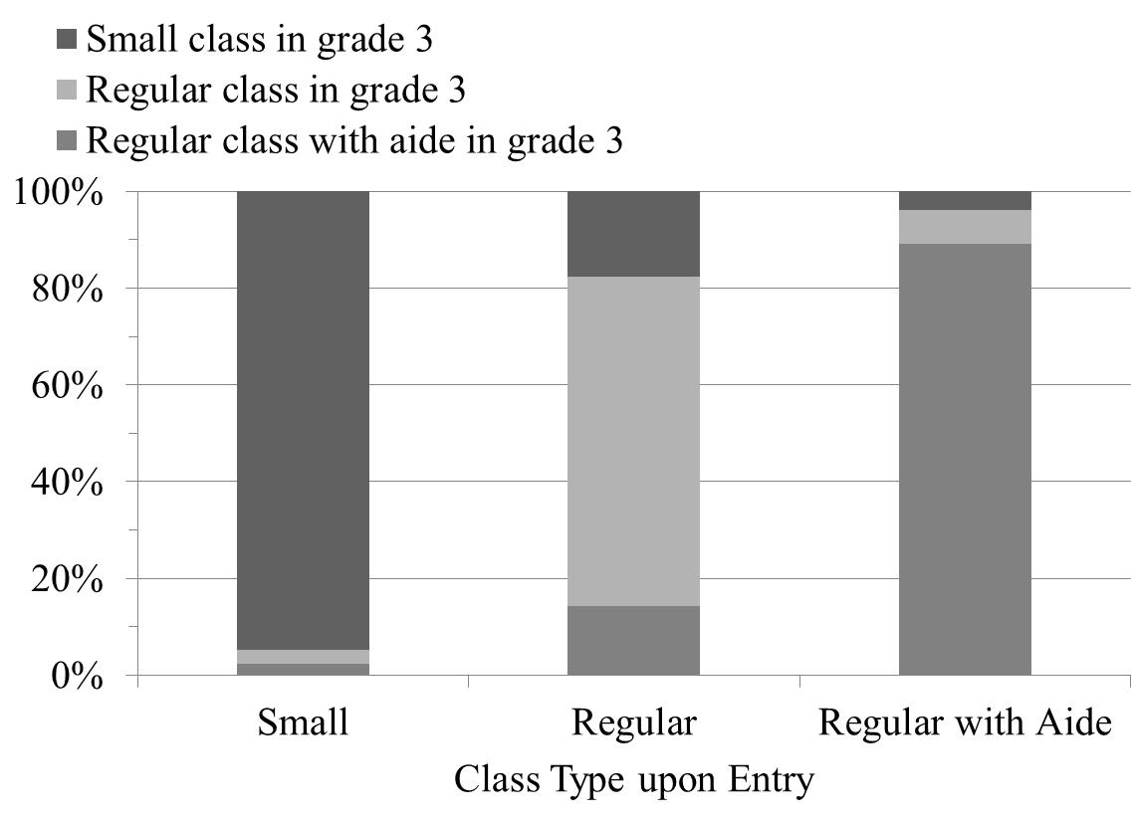

Panel C: Entered Project STAR in Grade 2

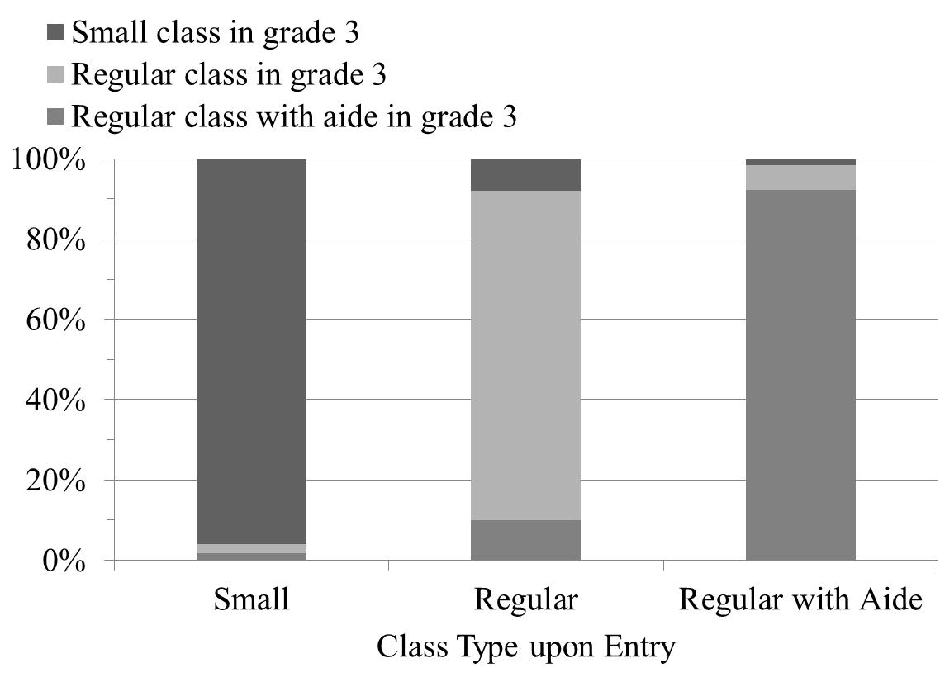

Notes to Figure 4: Sample is restricted to students who were in Project STAR in third grade in the same school as in the year of entry. Additional details in the text.

Figure 5: Grade Repetitionin Project STAR by Year of Entry and Initially Assigned Class Type

Panel A: Teacher Recommended Grade Repetition in Some Project STAR Year

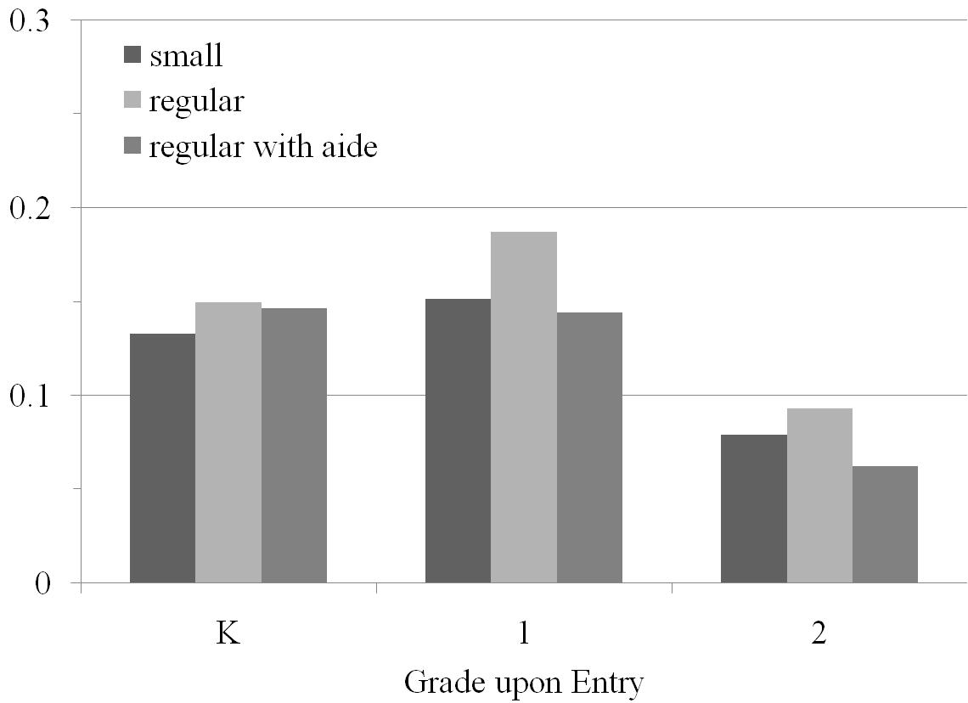

Panel B: Took TCAP in 1995 or Later

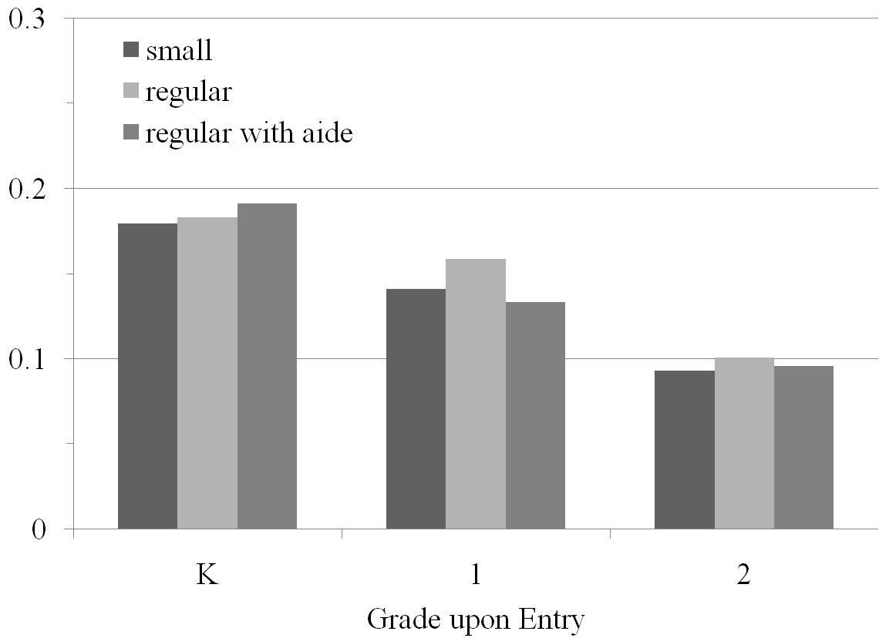

Notes to Figure 5: “Teacher recommended grade repetition” taken from Project STAR data; sample includes all students whose schools did not leave the program. Because the TCAP was only taken through eighth grade, a student in the STAR cohort who was making regular progress would not have taken the TCAP in 1995 or later. Hence, this outcome indicates that the student remained in the public school system through 1995 and repeated at least one grade.